Definition: Function

**Definition**: A function f from a set A to a set B is an assignment

of exactly one element of B to each element of A.

◆ We write *f*(a)=b if b is the unique element of B assigned by the

function f to the element a  A.

◆ If *f* is a function from A to B, we write

***f*: A → B**

This can be read as ‘*f* maps A to B’

◆ Note the subtlety

◆ Each and every element of A has a single mapping

◆ Each element of B may be mapped to by several elements in A or not

at all

Terminology

◆ Let *f*: A → B and *f*(a)=b. Then we use the following terminology:

◆ A is the domain of *f*, denoted dom(*f*)

◆ B is the co-domain of *f*

◆ b is the image of a

◆ a is the preimage (antecedent) of b

◆ The range of f is the set of all images of elements of A, denoted rng(*f*)

Function: Visualization

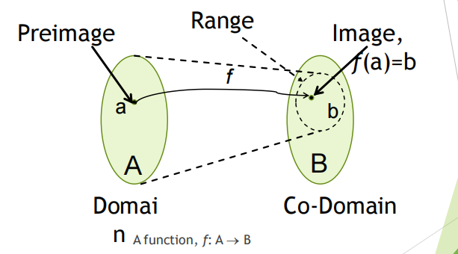

**Properties**

– **One-to-one (injective)**

– **Onto (surjective)**

– **One-to-one correspondence (bijective)**

Definition: Injection

◆ **Definition**: A function *f* is said to be one-to-one or

injective (or an injection) if

 x and y in in the domain of *f*, *f*(x)=*f*(y)  x=y

◆ Intuitively, an injection simply means that each

element in the range has at most one preimage

(antecedent)

◆ It is useful to think of the contrapositive of this

definition

x  y  *f*(x)  *f*(y)

Functions: Example 1

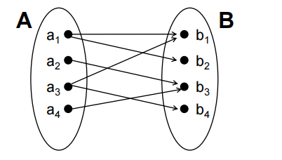

Is this a function? Why?

No, because each of a1 , a3 has two images

Definition: Surjection

◆ **Definition**: A function *f*: A→B is called onto or surjective (or an surjection) if

 bB,  aA with *f*(a)=b

◆ Intuitively, a surjection means that every element in the codomain is mapped

into (i.e., it is an image, has an antecedent)

◆ Thus, the range is the same as the codomain

Functions: Example 2

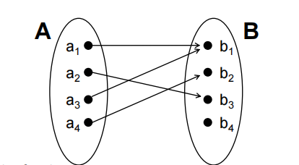

Is this a function

◆ One-to-one (injective)? Why?

◆ Onto (surjective)? Why?

No, b1 has 2 preimages

No, b4 has no preimage

Definition: Bijection

◆ **Definition**: A function *f* is a one-to-one

correspondence (or a bijection), if is both one-to-one

(injective) and onto (surjective)

◆ One-to-one correspondences are important because

they endow a function with an inverse.

◆ They also allow us to have a concept cardinality for

infinite sets

◆ Let’s look at a few examples to develop a feel for

these definitions…

Functions: Example 3

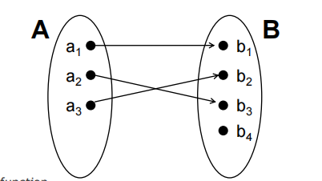

◆ Is this a function

◆ One-to-one (injective)? Why?

◆ Onto (surjective)? Why?

Yes, no bi has 2 preimages

No, b4 has no preimag

Functions: Example 4

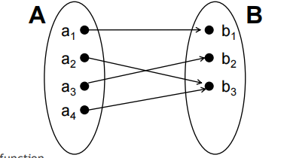

◆ Is this a function

◆ One-to-one (injective)? Why?

◆ Onto (surjective)? Why?

No, b 3 has 2 preimages

Yes, e very bi has a preimage

Functions: Example 5

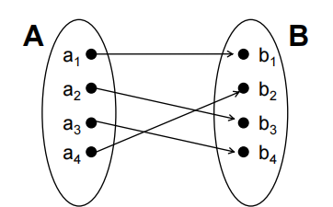

◆ Is this a function

◆ One-to-one (injective)?

◆ Onto (surjective)?

Thus, it is a bijection or a

one-to-one correspondence